AIM:
To measure Low resistance using Kelvin's double bridge
APPARATUS REQUIRED:
•Virtual lab
THEORY:
Introduction
Kelvin Double Bridge for Low resistance Kelvin's double bridge may be used for precision measurement of four-terminal low resistances. Four terminal resistors have two current leading terminals and two potential terminals across which the resistance equals the marked nominal value. This is because, the current must enter and leave the resistor in a fashion that there is same or equivalent distribution of current density between the particular equipotent surfaces used to define the resistance. The additional points also eliminated any contact resistance at the current lead-in terminals.
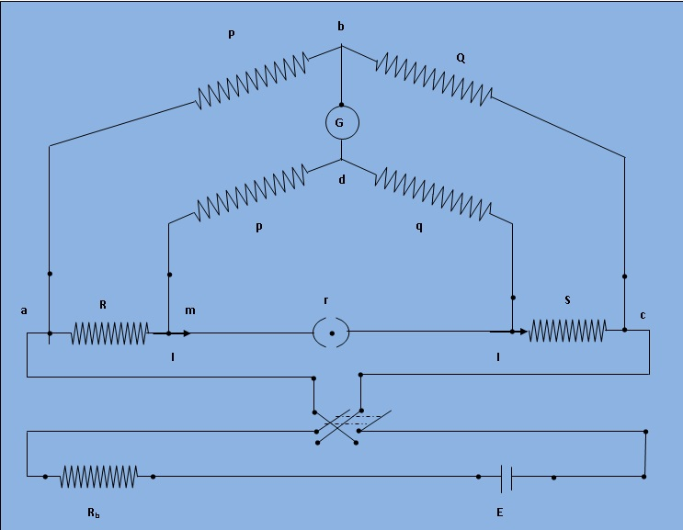
Fig.1: Schematic diagram for measurement of low resistance by Kelvin double bridge
Theory
The kelvin double bridge incorporates the idea of a second set of ratio arms - hence the name double bridge- and the use of four terminal resistors for the low resistance arms. Figure 1 shows the schematic diagram of kelvin bridge. The first ratio arms are P and Q. The second set of ratio arms p and q is used to connect the galvanometer to a point d at the appropriate potential between points m and n to eliminate the effect of connecting lead resistance r between the unknown resistance R and the standard resistance S.
The ratio p/q is made equal to P/Q. Under balance conditions there is no current through the galvanometer which means that the voltage drop between a and b, E_{ba} is equal to voltage drops E_{mad} between a and c.
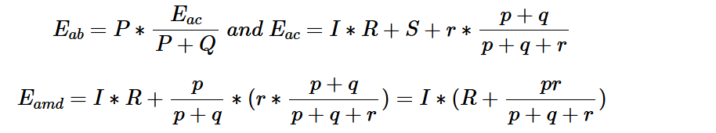
for zero galvanometer deflection, Eba=Emad
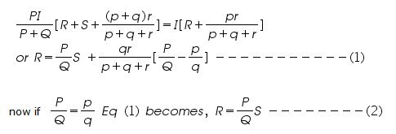
Eq (2) is the usual working equation for the kelvin bridge. It indicates that the resistance of connecting lead, r, has no effect on the for zero galvanometer deflection, Eba=Emad
Eq (2) is the usual working equation for the kelvin bridge. It indicates that the resistance of connecting lead, r, has no effect on the
PROCEDURE:
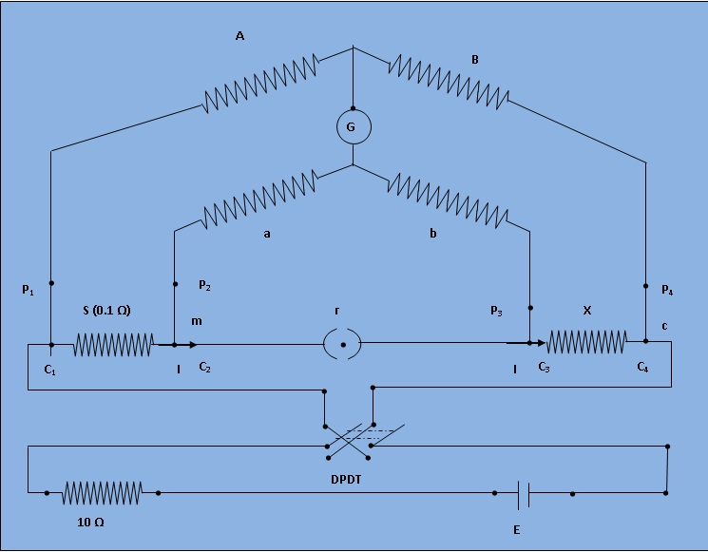
Figure 1: The circuit diagram for experimental set-up of Kelvin Double Bridge

- Connect the circuit as shown in the Fig. 1.
- Set the value of the resistances A and a at 1000 ohm by setting the plugs at the marked positions and the values of B, b at 1000 ohm by setting the dial. Open the Key K. The bridge will act as a whetstone bridge. A null deflection Galvanometer will ensure the relationship A/a = B/b.
- Close the key K. Adjust the rheostat to obtain 2A current in the circuit.
- Keeping the resistances A, a at 1000 ohm, vary B, b to obtain the Galvanometer null. Note the value B, b at balance position from the dial.
- Reverse the direction of current by operating the two-way switch 's' and obtain the balance.
- Set the values of A, a at 1 ohm and 1000-ohm position and repeat step 5 and step 4.
- Repeat step 5 through step 6 for different line currents 3A, 4A and 5A.

SIMULATION:
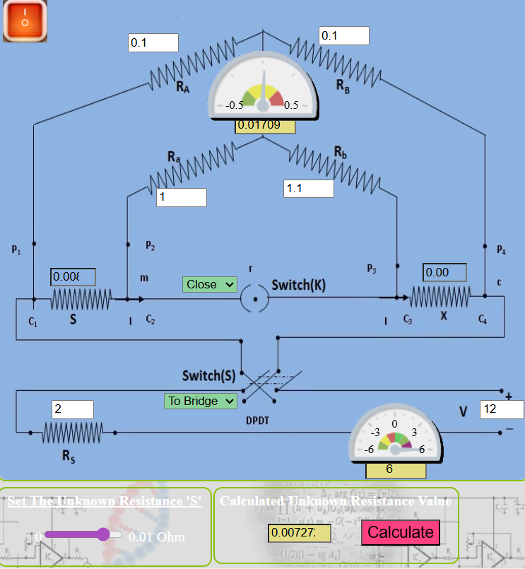
Unknow resistance value=0.00727

RESULT:
Thus, the unknown resistance is found using kelvin’s double bridge using Virtual lab.

